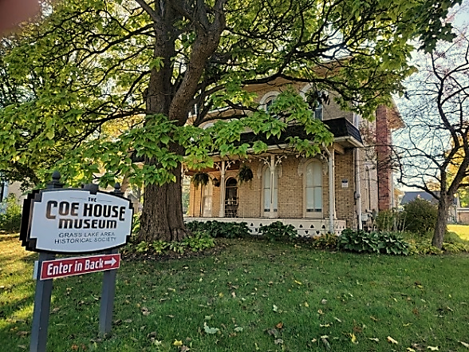
We would like to thank you for your support that has helped us to continue operation. The society functions under the original 1971 name Grass Lake Area Historical Society (GLAHS), whose mission is to serve the historical needs of the area and its families. The GLAHS is a nonprofit 501(c)(3) organization.
The Coe House, found on the corner of Michigan Avenue and Wolf Lake Road, in Grass Lake, Michigan; has been the home of the GLAHS since 1972. The building itself was constructed in 1871.
From the surrounding communities the museum has been fortunate to receive family histories and heirlooms which are displayed in the “Alumni Room”. Throughout the museum you will find class composites, 1880 memory books, early settler diaries, collectible schoolroom books, yearbooks including a 100-year-old GLHS yearbook, early classroom photos and framed GLHS diplomas, just to name a few items.
The museum hosts events such as the vintage wedding dress display, fabric gala, sale of cookbooks containing classic recipes and a cemetery walk. The museum participates in many Grass Lake events – Heritage Day, Holiday Cookie Tour, Veterans offerings, as well as the Jackson County Museum Day. Our website shares “100 Years Ago” articles from the former Grass Lake News.
GLAHS continues to coordinate events in conjunction with those promoted by the Lost Rail Museum, the Grass Lake Alumni Association, Grass Lake Village, Grass Lake DDA, Grass Lake Whistlestop Depot, Grass Lake Senior Center, Jackson County Michigan Historical Society, Experience Jackson, and The Peaches & Patches Quilt Guild.
A grant from the Phil & Pat Willis Foundation will enable the GLAHS to purchase equipment needed to digitize donated pictures and documents. The digitized items of historic significance will be available to GLAHS members.
We also appreciate the business donations, “In Memory” bequests from family members, the Grass Lake Village Grounds crew for keeping the lawn in tip-top shape, and the numerous volunteers who have given their unequivocal support.
How can you help? Become a member. Donate artifacts and stories. Share ideas for events or programs. Please help sustain the museum with your financial support.
Questions? Contact the museum at coehousemuseum@gmail.com or call: Patricia Simpson @ 517 748 1078
_____________________________________________________________________________________________2023 MEMBERSHIP APPLICATION & MEMBERSHIP FEES
Make check payable to: GLAHS and mail form to:
GLAHS; P.O. Box 782; Grass Lake, MI 49240

Individual ($20)_____ Family ($30)_____ Business ($100)_____ Other_____

Name:________________________________________________________________________________________

Address:______________________________________________________________________________________

Email:_______________________________________________________Phone:___________________________

